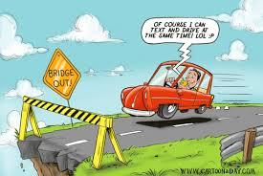
Texting while driving

Please answer the first two questions before reading the article.
- Which of the following do you think is more dangerous? (A) Texting while driving (B) Talking on the phone while driving
- It is safer to use a hands-free phone than a hand-held one. (A) True (B) False
Now read this article:
https://www.usatoday.com/story/money/cars/2014/03/28/cellphone-use-1-in-4-car-crashes/7018505/
- According to the article, which of the following is more dangerous? (A) Texting while driving or (B) Talking on the phone while driving
- Is it safer to use a hands-free phone than a hand-held one. (A) True (B) False
Consider this: 11 teens die every day as a result of texting while driving. According to an AAA poll, 94% of teen drivers acknowledge the dangers of texting and driving, but 355 admitted to doing it anyway. 21% of teen drivers involved in fatal accidents were distracted by their cell phones.
- Write at least a paragraph explaining your reaction to this article and this assignment.

